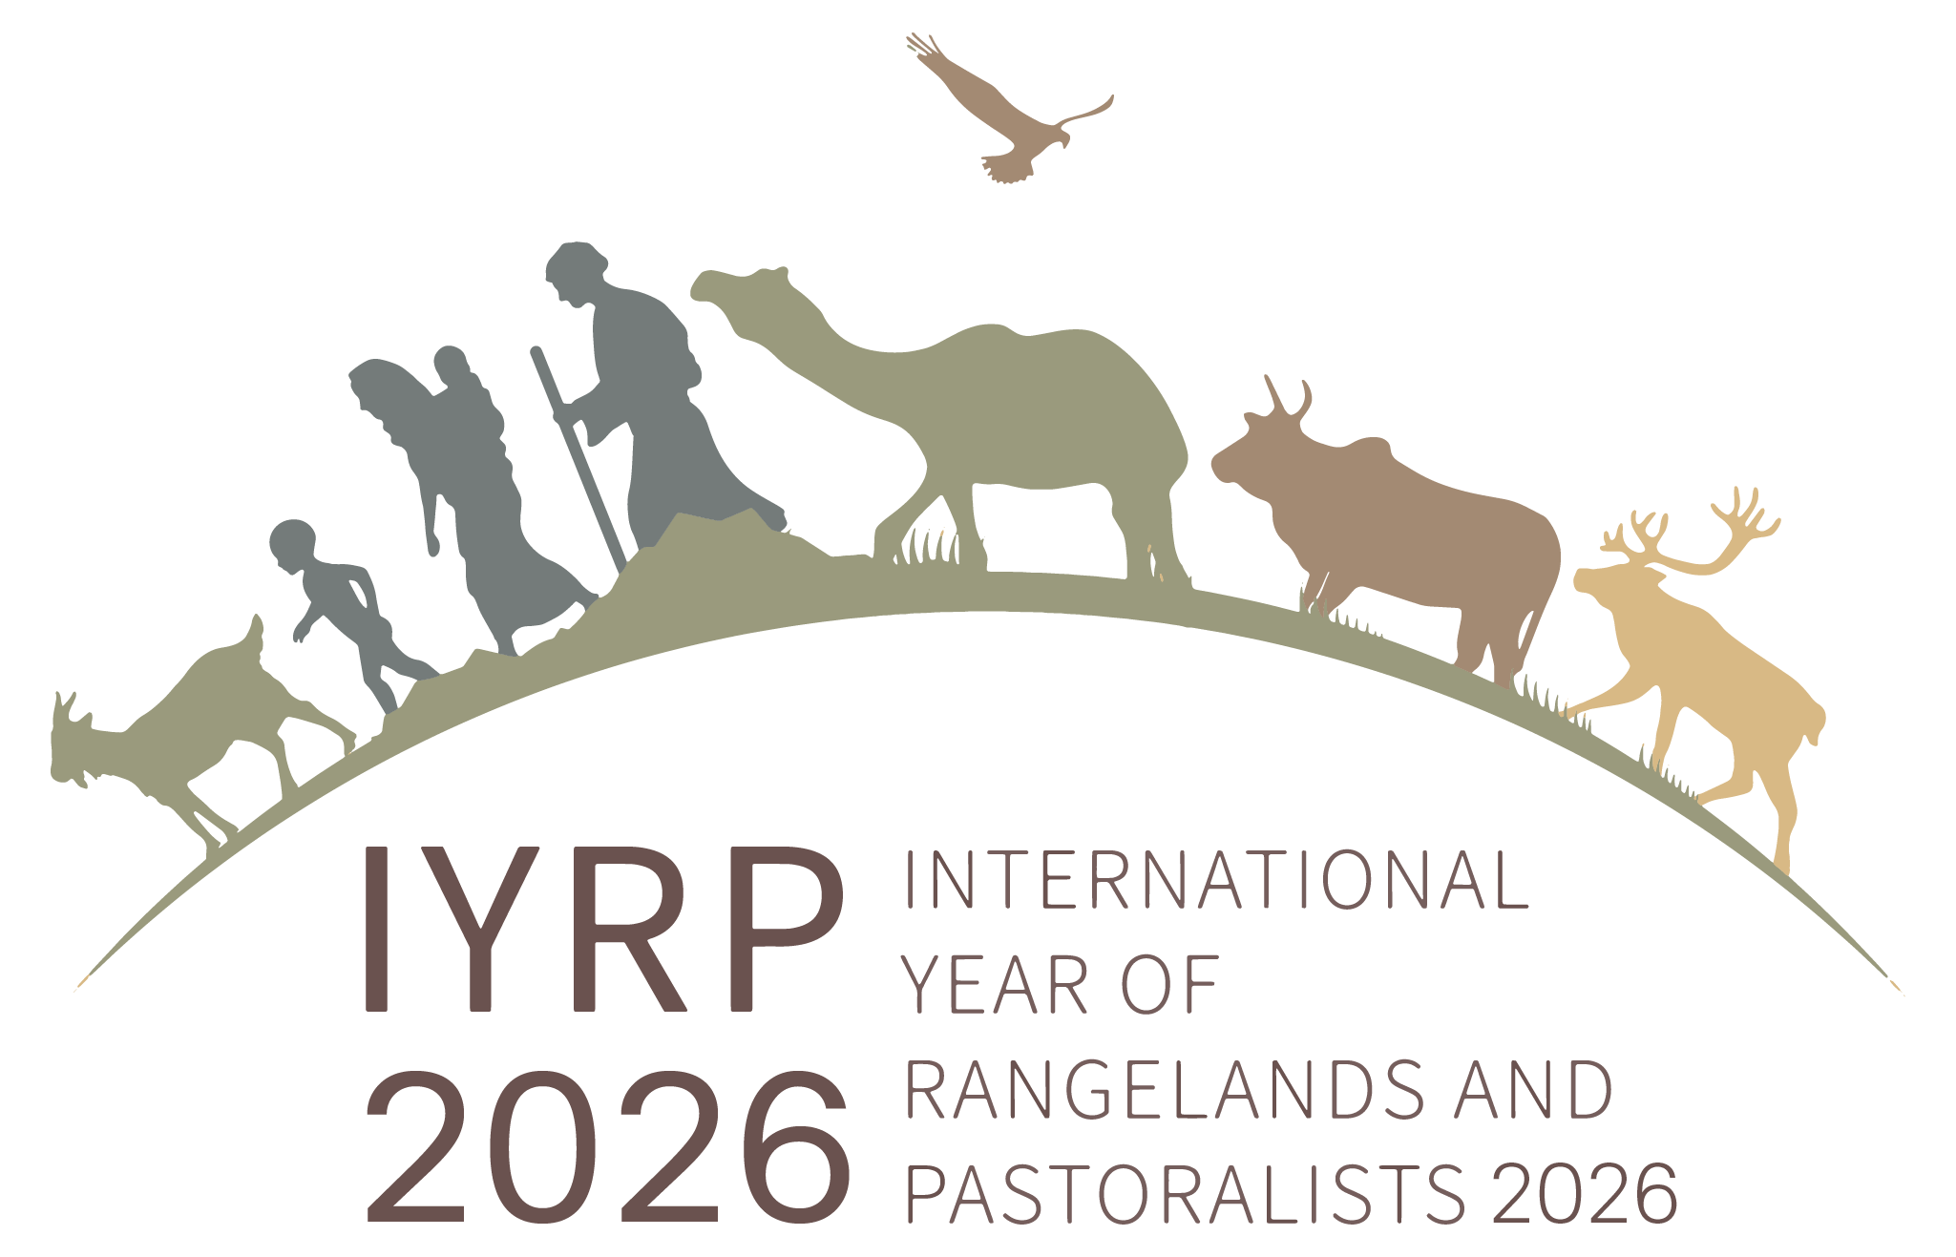

Stockholm+50 Side Event: Nature-based restoration and multipurpose use
of rangelands: promising solutions to benefit our planet and people
2 June 2022

The IYRP co-organised a side event at the international conference “Stockholm+50: a healthy planet for the prosperity of all – our responsibility, our opportunity”, which took place on 2–3 June 2022, 50 years after the 1972 UN Conference on the Human Environment. Members of the IYRP Global Coordination Group were involved in several Informal Working Groups preparing for the conference. On 2 June, the side event on "Nature-based restoration and multipurpose use of rangelands: promising solutions to benefit our planet and people", attracted over 350 participants in person and online. It made a call for three actions related to rangelands and pastoralists:

Action 1: Stockholm+50 to call on countries to urgently stop conversion of rangelands, including grasslands and savannahs, and to restore 50% by 2030 through sustainable, participatory nature-based solutions.

Action 2: Stockholm+50 to call on countries and the private sector to ensure that deployment of large-scale renewable energy schemes in rangelands, including grasslands and savannahs, are mutually beneficial for pastoralists and ecosystems without unintended negative social and environmental impacts.

Action 3: To strengthen a global coalition/platform for the sustainable stewardship and nature-based restoration of rangelands, including grasslands and savannahs (recently presented at UNCCD COP 15), securing sustainable livelihoods for all pastoralists and benefiting the planet.

For more information, see https://iyrp.info/stockholm50

